Project 2, November 11, 2018  
Data Visualization, FA18-CPSC-53000-001

**Mapping Flight-Paths in Tableau**

**Eric Lazarski, Walaa Yakoub**

Lewis University  
One University Parkway  
Romeoville, IL 60446-2200

**ABSTRACT**

The purpose of this paper is to visualize airlines paths on geographical map by combining two complimentary datasets. This paper explains the datasets we used, the process of combining datasets, working with them in Tableau, the development of a hypothesis and the development of a persuasive story in Tableau.

**INDEX TERMS**

IATA: The International Air Transport Association is a trade association of the world’s airlines

**I. INTRODUCTION**

Destination Maps geographically show the movement of objects, people, animals, or products from one location to another and their amount. This paper is demonstrating the flight-paths from the original departure airport to destination arrival airport for each airline and shows the most active airlines and airports. The dataset has been provided by Contentshare Pte Ltd. and it is available on

https://openflights.org/data.html

**II. THE DATASETS**

The two datasets used report on routes and airports. The routes file contains only route information, with column headers of *airline, airline id, source airport, source airport id, destination airport, destination airport id, codeshare, stops, and equipment*. This routes file contains 67663 routes between 3418 airports on 568 airlines. The airports dataset contains information regarding airports. The column headers here are *airport id, name, city, country, iata, icao, latitude, longitude, altitude, timezone, dst, tz database time, type, source*. This routes file contains 7184 airport, 5654 airports only are known as an IATA location identifier.

**III. COMBINING THE DATASETS**

In order to draw a route, Tableau needs two different rows, one for origin airport, another one for destination airport, essentially two airports with latitude and longitude. Additionally, you need to create “Path ID” field in both rows, which connects one airport to the other.

Firstly, to duplicate the records in “Routs” table we used “Self-Union” as shows in figures 1

Self-Union - Figures 1

Secondly, to create a new “Path ID” column we used the following formula:

*IF RIGHT([Table Name], 1) == "1" THEN 2 ELSE 1 END*

Thirdly, we joined file “Routs” table with “Airports” table to connect each start and end points with their latitude and longitude GPS coordinates by using the following join condition as per figures 2

*IF RIGHT([Table Name], 1) == "1" THEN [Destination airport ID] ELSE [Source airport ID] END*

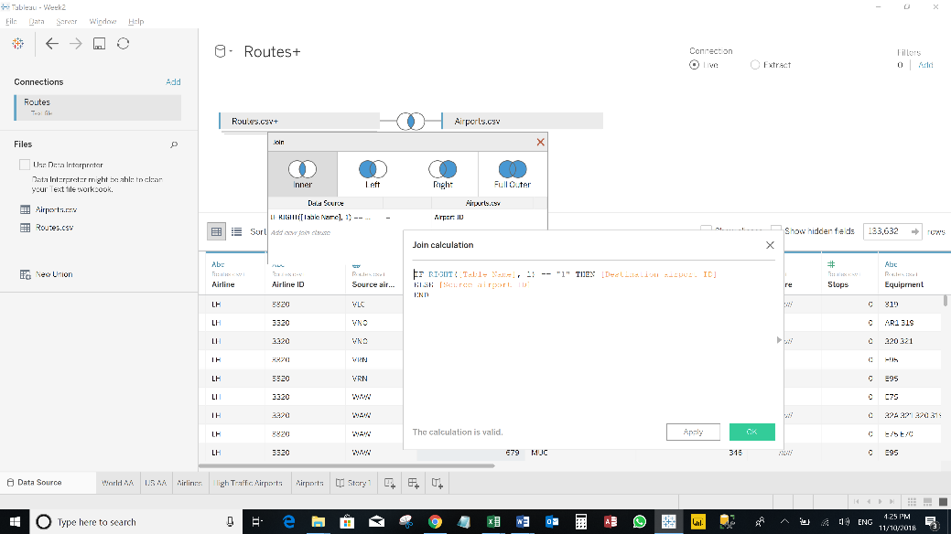Inner Join - Figures 2

**IV. WORKING WITH DATA IN TABLEAU AND THE DEVELOPMENT OF A HYPOTHESIS**

It was apparent that this data could be utilized to draw airline routes in Tableau. Thus, we can compare and differentiate the performance of each airlines in certain area by filter airline and country. Moreover, we can identify the airports which have most count of flights paths for every airline. For the project, we opted to look at American Airlines and United Airlines.

**V. DEVELOPMENT OF A STORY**

1. ***WORLDWIDE OVERVIEW***

While we clearly notice from figures 3 and 4 that the most flights paths connect between airport in North America, Europe and China, we can see from figures 5 that U.S. has the most count of flights paths.

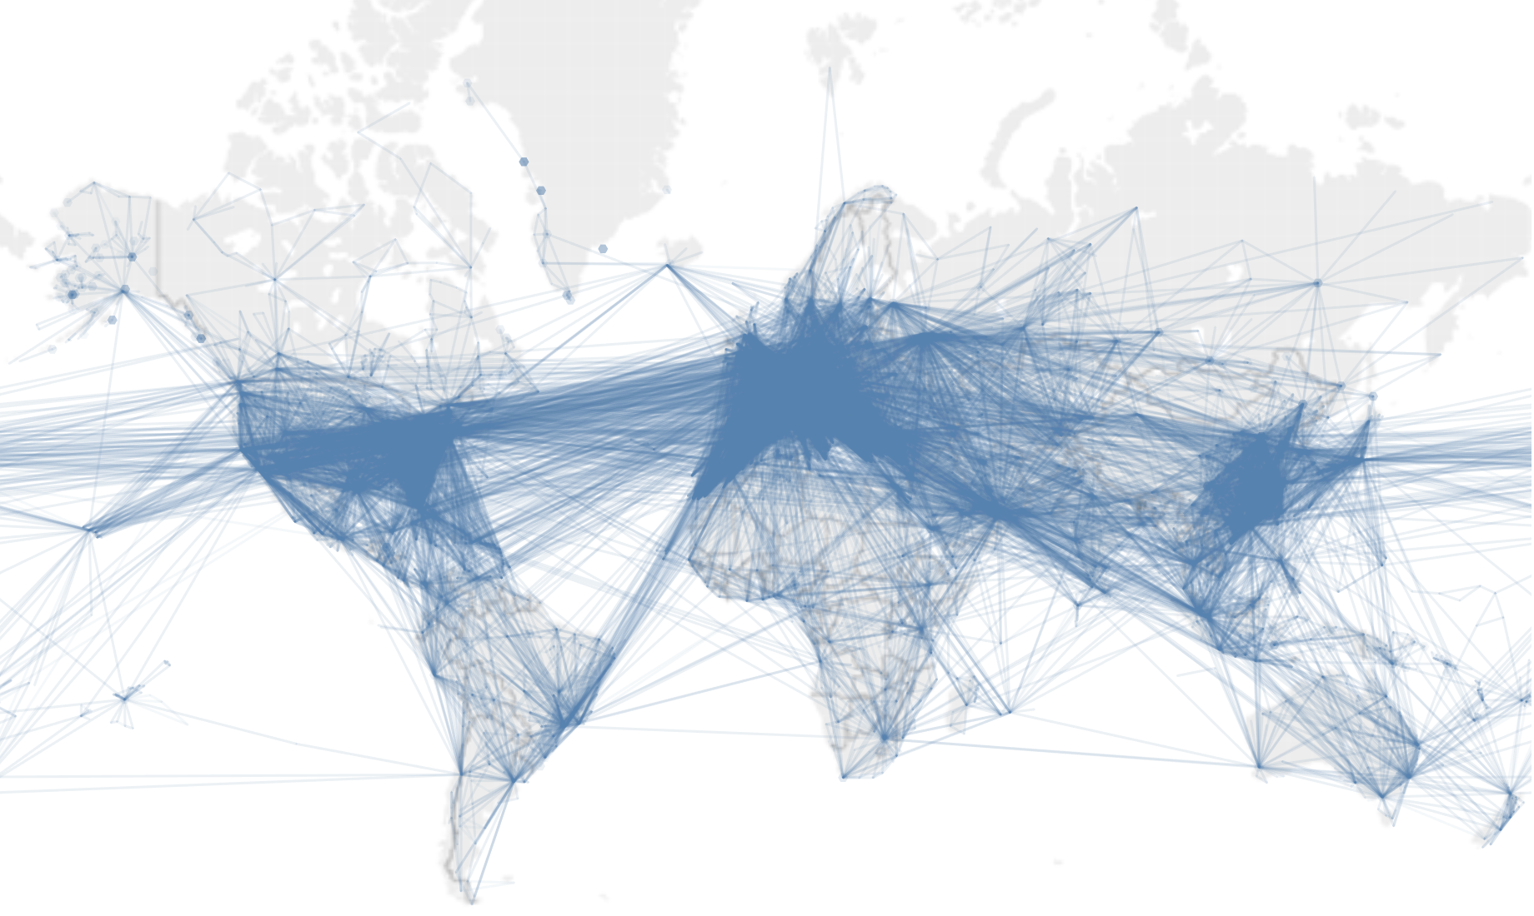 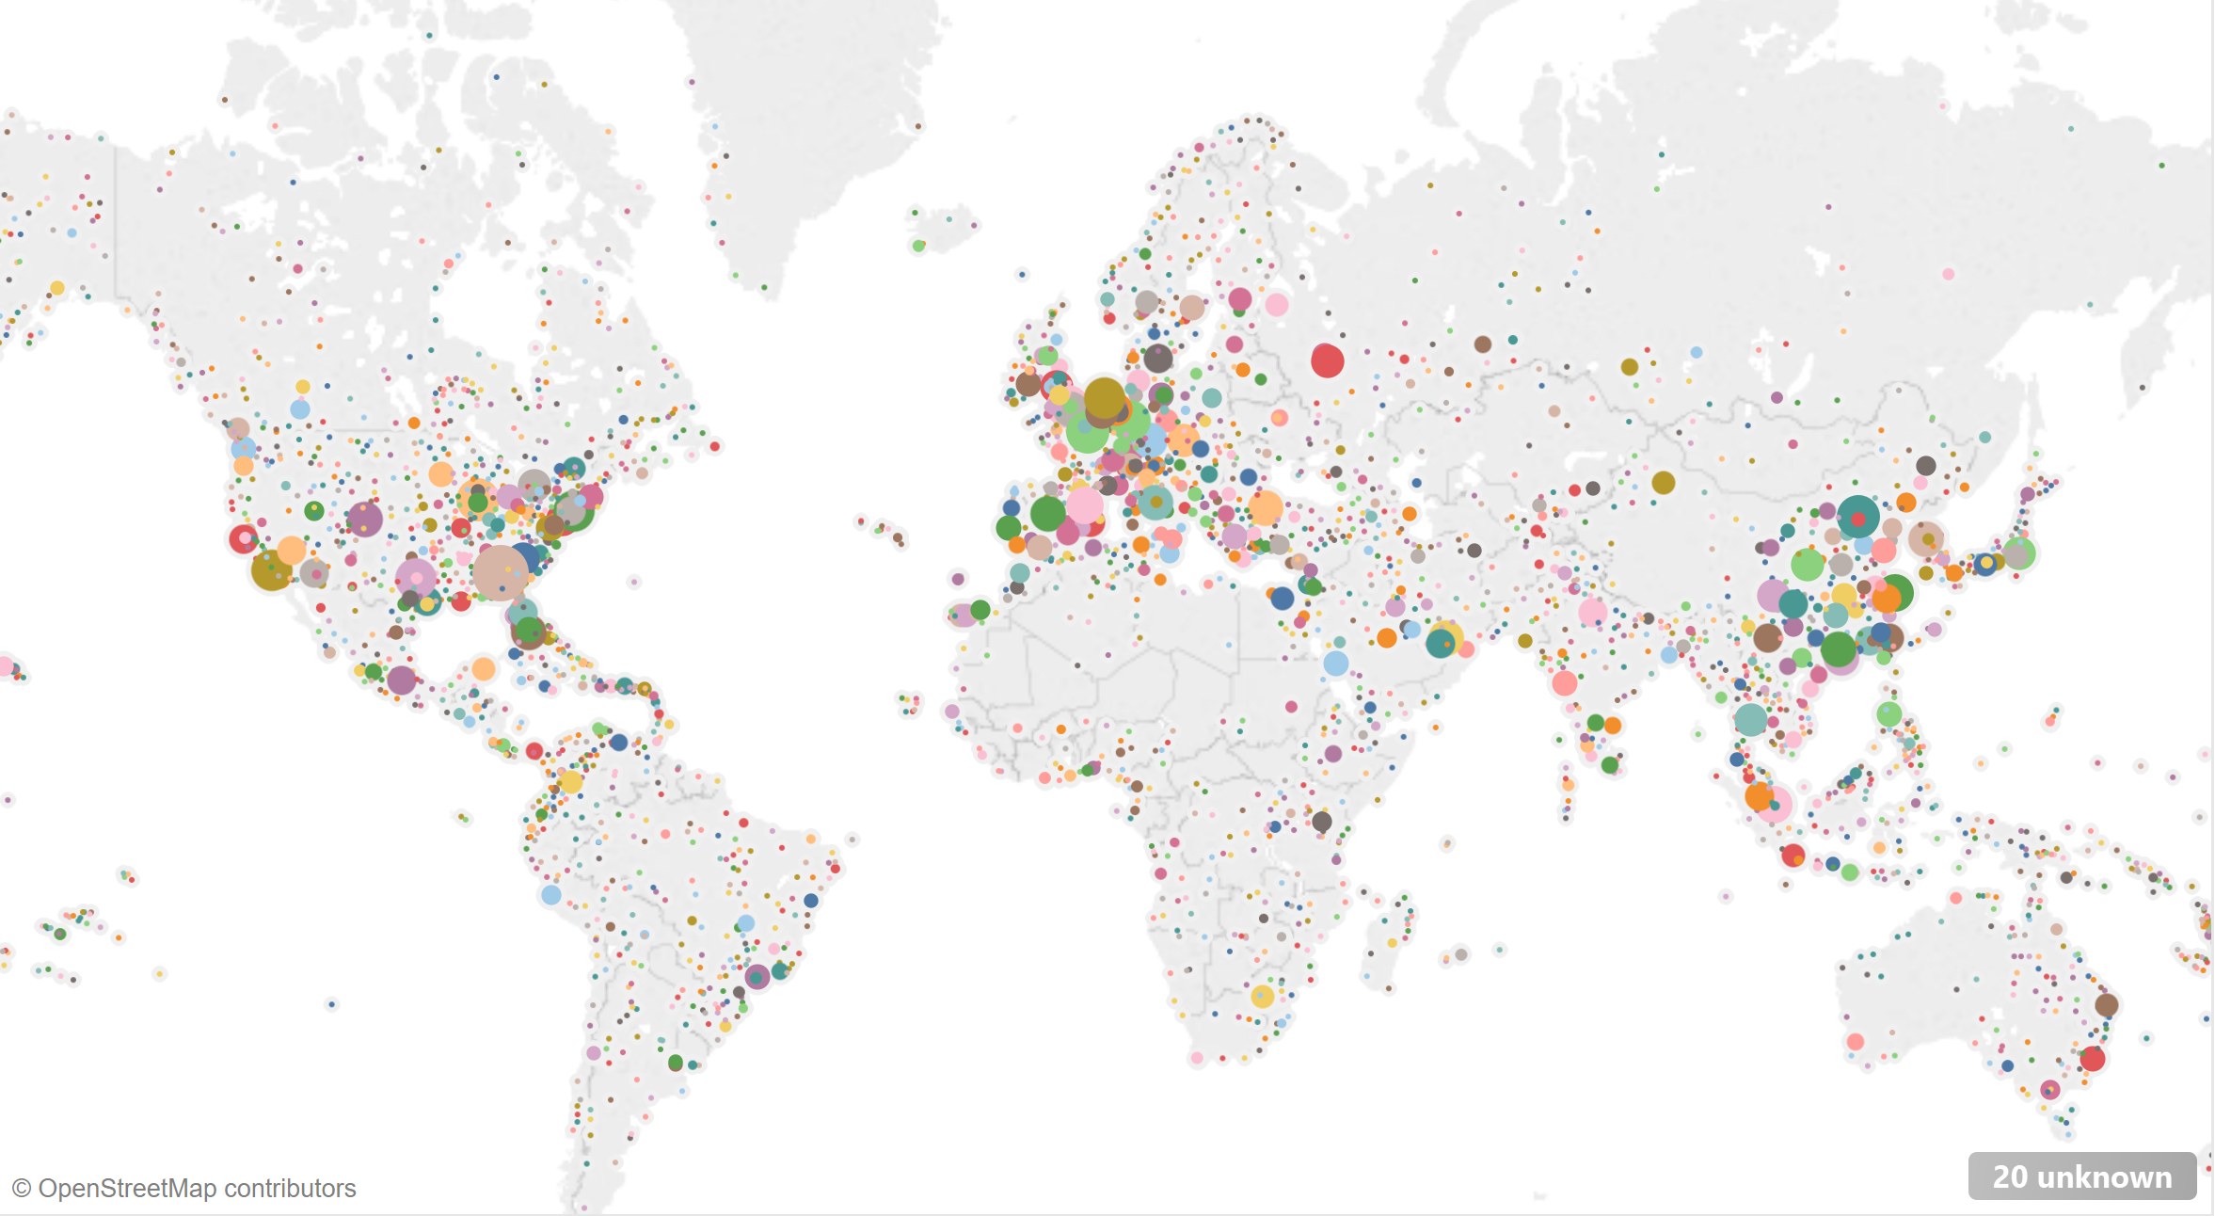  
 Line of paths - Figures 3 Count of paths per airport - Figures 4

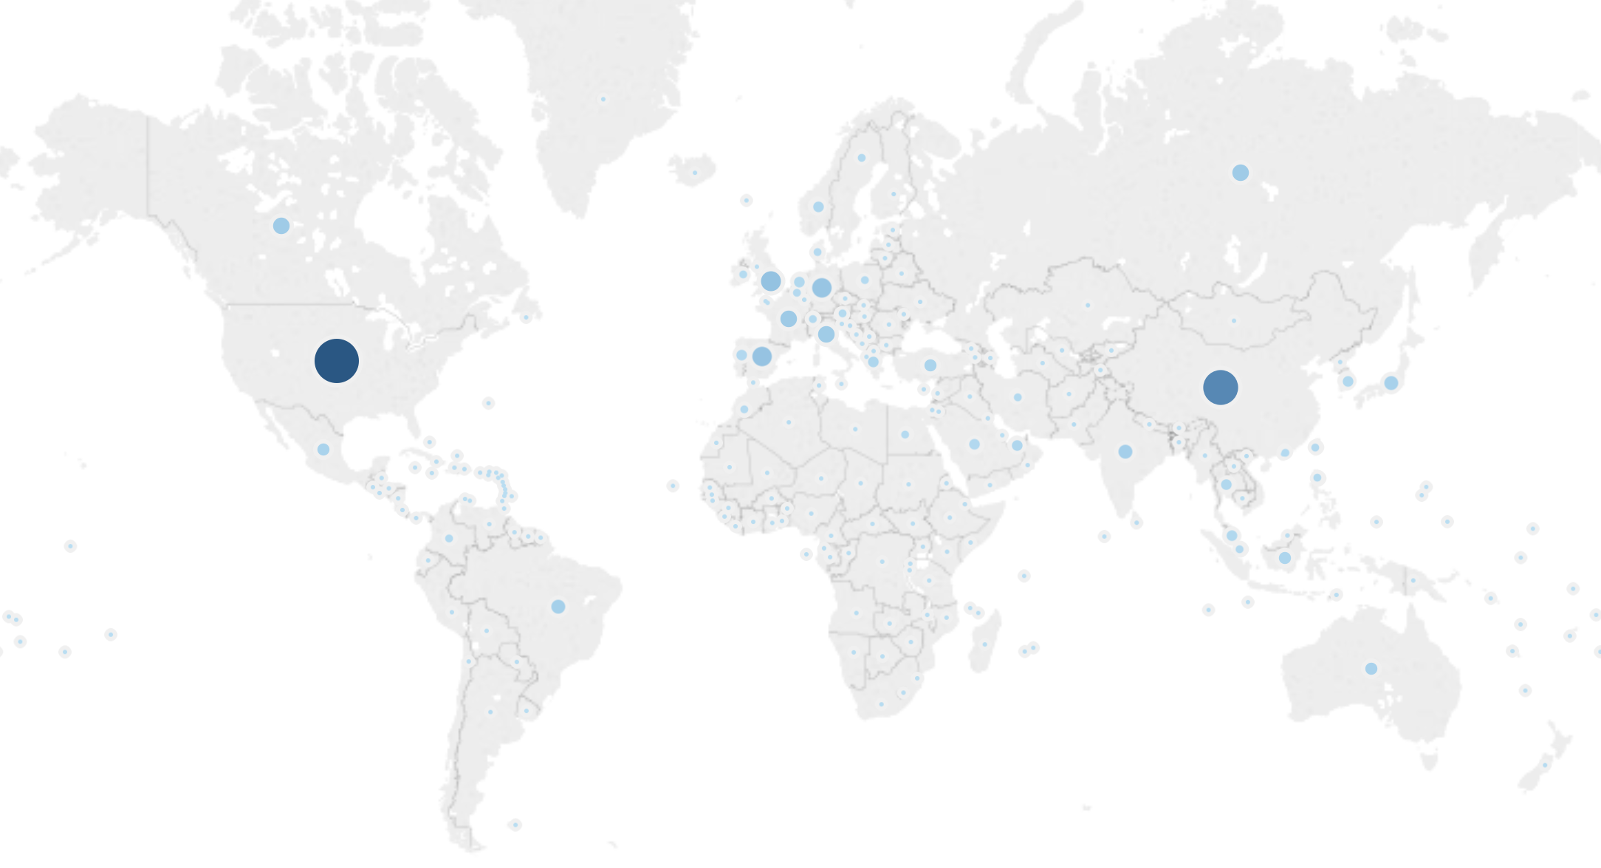  
 Count of paths per country - Figures 5

1. ***AIRLINES IN U.S.***

The tree map in figures 5 illustrate the count of flights paths for each airline in U.S, and we can notice that the American Airlines, United Airlines, Delta Airlines and US Airways respectively have the most count of flights paths in U.S.

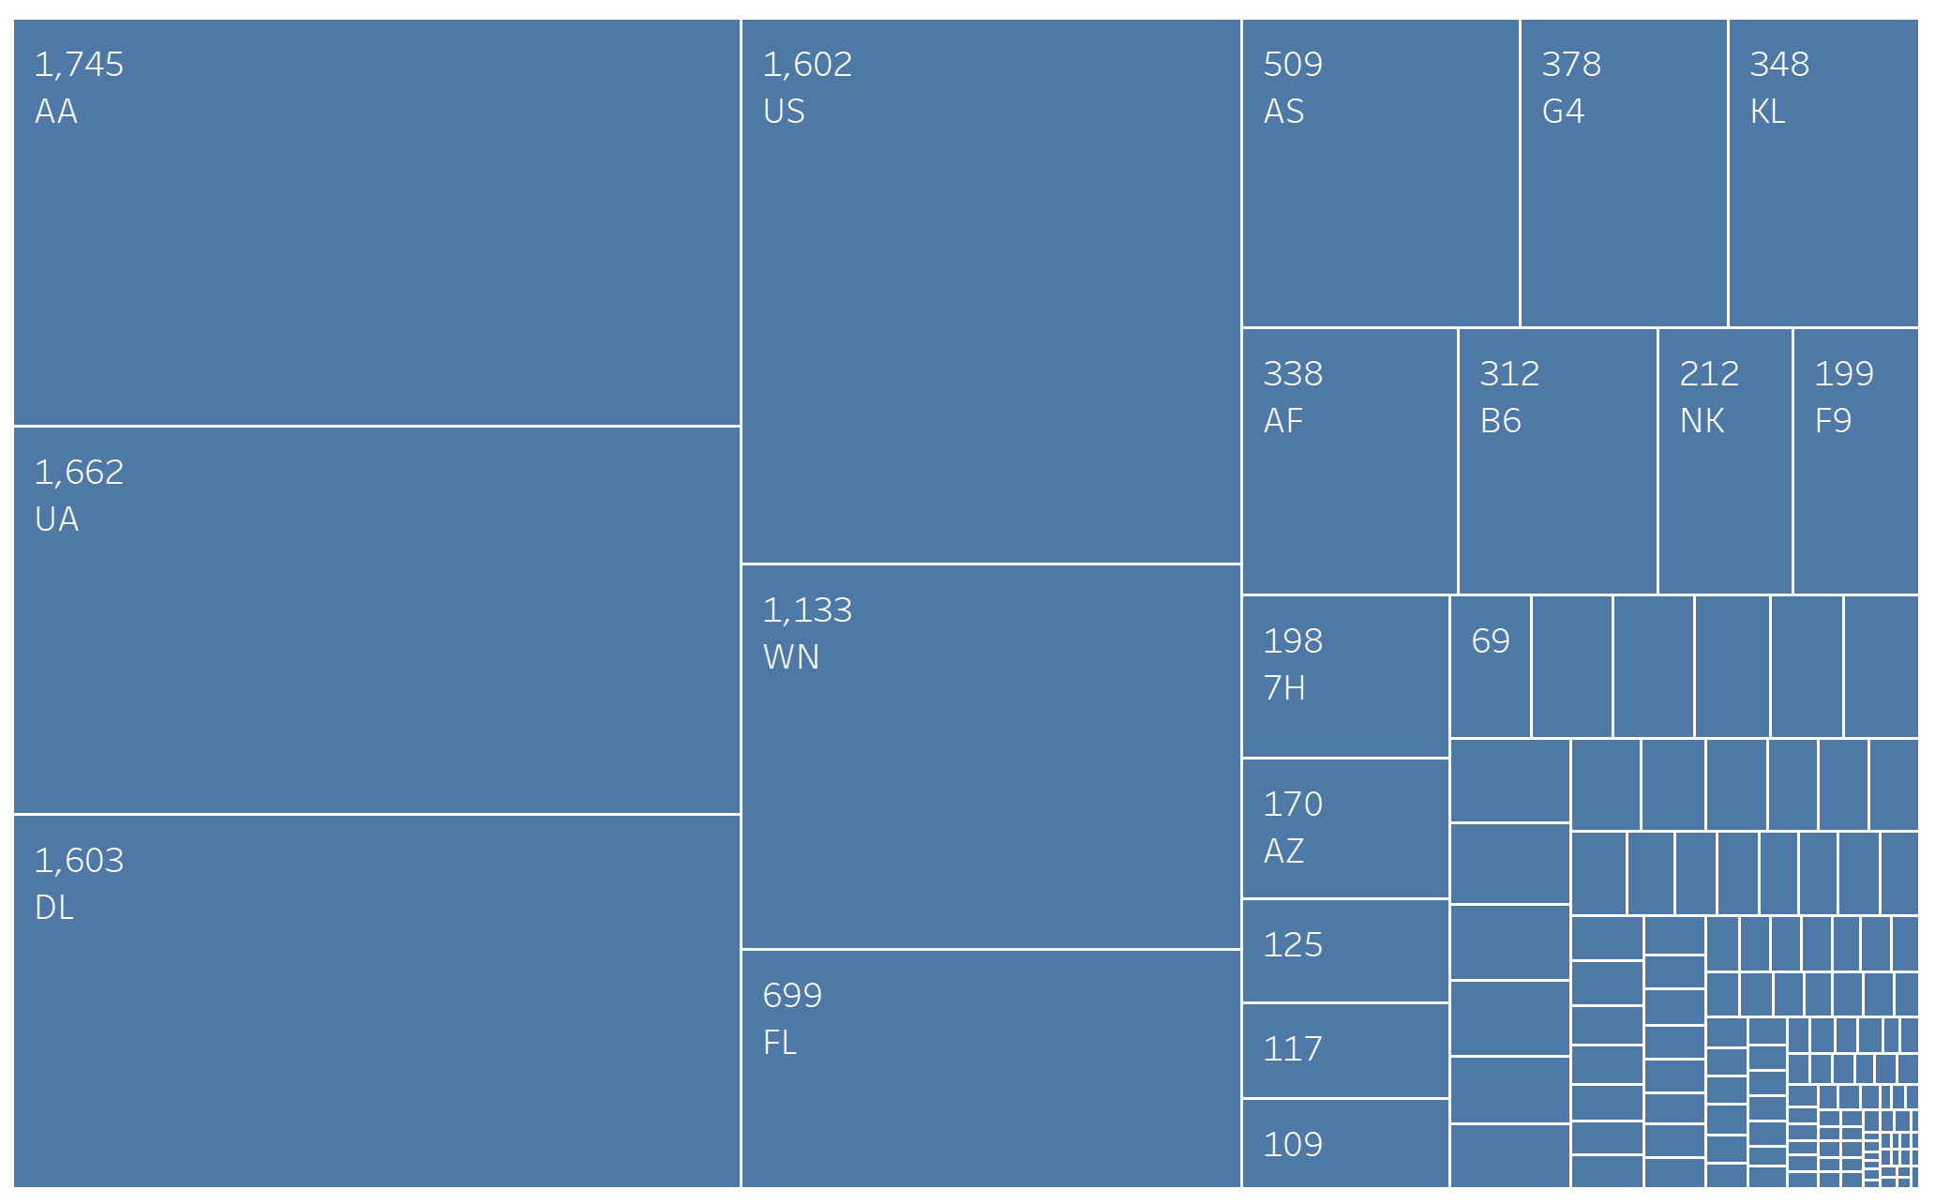

Count of paths per airline in U.S. - Figures 6

1. ***AMERICAN AIRLINES VS UNITED AIRLINES (DOMESTIC AND INTERNATIONAL FLIGHTS)***

The two geographic maps in figures 7 show the comparison between American Airlines paths and United Airlines paths. By focusing on international flights, we can see that American Airlines has more flight paths to Latin America and Australia. Additionally, American Airlines has a strong hub in Europe to connect India and Malaysia

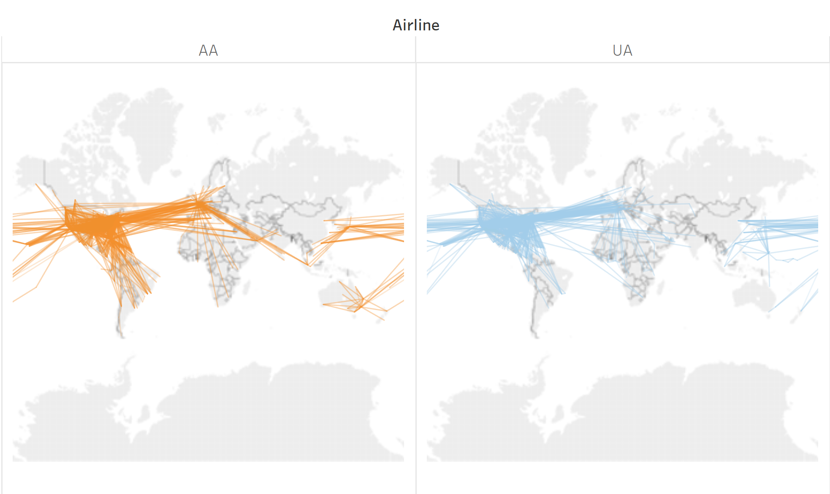

Flights paths for American Airlines and United Airlines - Figures 7

1. ***AMERICAN AIRLINES VS UNITED AIRLINES (DOMESTIC FLIGHTS)***

From figures 8 and 9, we can notice that; While United Airlines has many flights paths to/from Colorado, Montana, Wyoming, North Dakota and South Dakota, American Airlines has very rare flights paths to serve these areas. On the contrary, While American Airlines has many flights paths to/from Florida, United Airlines has few flights paths to serve this aria.

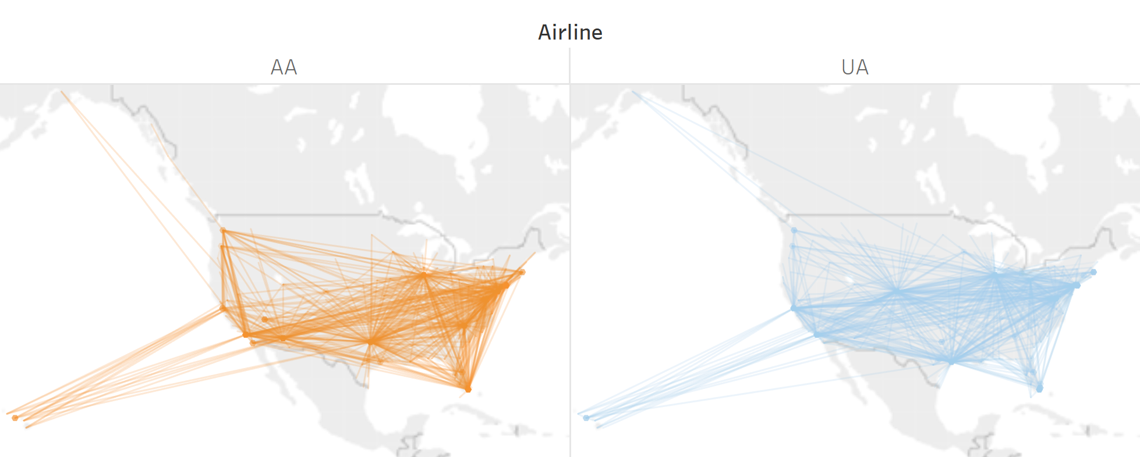

Domestic flights paths for American Airlines and United Airlines - Figures 8

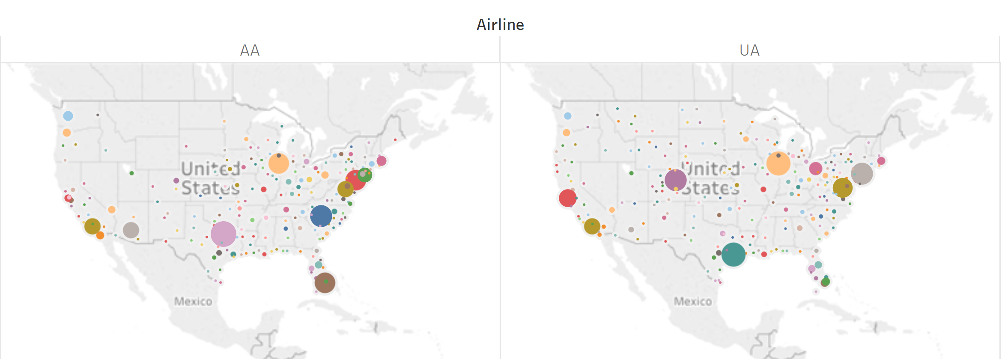

Count of domestic flights paths per airport for American Airlines and United Airlines - Figures 9

**VI. CONCLUSIONS**

Based on the above graphs and analysis, our recommendations are as follows:

* For United Airlines:
  + Making the necessary feasibility study of developing more flights paths to/from Australia, India and Latin America.
* For American Airlines:
  + Making the necessary feasibility study of developing more flights paths to/from West and Midwest Regions in U.S.

**VII.  REFERENCES**

Airport base data was generated by from DAFIF (October 2006 cycle) and [OurAirports](http://ourairports.com/), plus timezone information from [EarthTools](http://www.earthtools.org/). All DST information added manually. Significant revisions and additions made by the users of OpenFlights.

Airline data was extracted directly from Wikipedia's gargantuan [List of airlines](http://en.wikipedia.org/en/List_of_airlines). Plane data from [List of ICAO aircraft type designators](https://en.wikipedia.org/wiki/List_of_ICAO_aircraft_type_designators). Significant revisions and additions made by the users of OpenFlights.

Route data is maintained by and imported directly from [Airline Route Mapper](http://arm.64hosts.com/). Duplicate entry removal and cross-referencing to airport/airline IDs by OpenFlights.